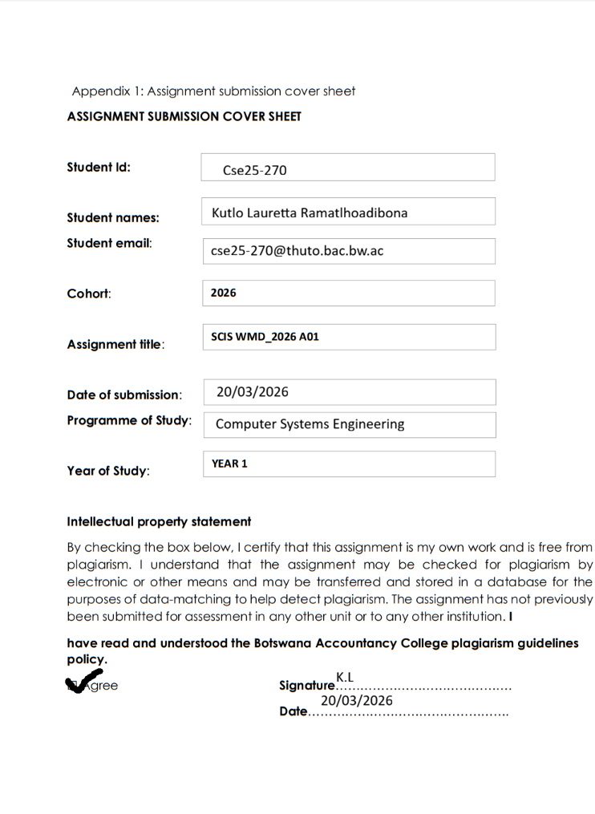
WEBSITE SPECIFICATIONS

. WEBSITE OBJECTIVE
- The main objective of Pula Scholars website is to educate and help Botswana students to apply for both local and international life changing scholarship opportunities regardless of their location or financial background.
- Empower young minds through global education.
- Guide students on how to apply.
- To assist students so that they have easy access to scholarship opportunities.

. WEBSITE GOAL
- The main goal of Pula Scholars is to build comprehensive and mobile friendly website that has at least 20 local and international scholarships and this goal supports Botswana’s goal of empowering young people with knowledge and skills.
-To raise awareness of both local and international scholarships opportunities.
-To help students to reach their academic and career goals.

. TARGET AUDIENCE
Demographics
-The target audience of Pula Scholars are young people both male and female aged of 16 and above who are intrigued in study outside the country, those seeking financial support for their studies, those who have completed their secondary education and those in tertiary institutions.
Aptitude
-Our target users are motivated students who are looking for scholarship opportunities to improve their education and know basic computer skills. This allows them to make their way through the website and search for information online.
. TYPE OF WEBSITE
Pula scholars is an informational , and simple online guide that provides details about scholarships and guides students how to apply and what is needed of them so that they can apply. This website brings together local and international scholarships from places like UK, USA and Australia all into one place for easy access.

INFROMATION DESIGN AND TAXONOMY

. INFORMATION STRUCTURE
The website is designed in such a way that it is simple, easy to interact with and it allows students to easily access information. The Main Menu/ Home Page provides information and links to other pages such as About & Contact, Apply now and most importantly the Help Page which provides easy guides on how to understand scholarships requirements such as international grades and steps on how to apply.

SITE MAP

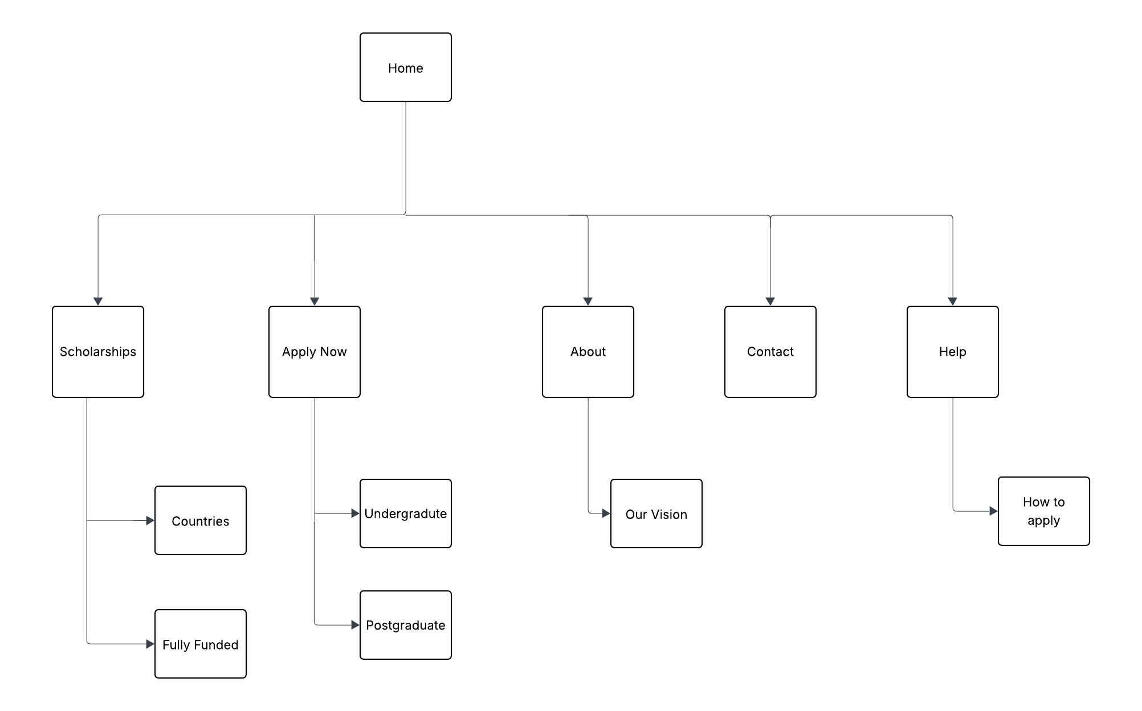

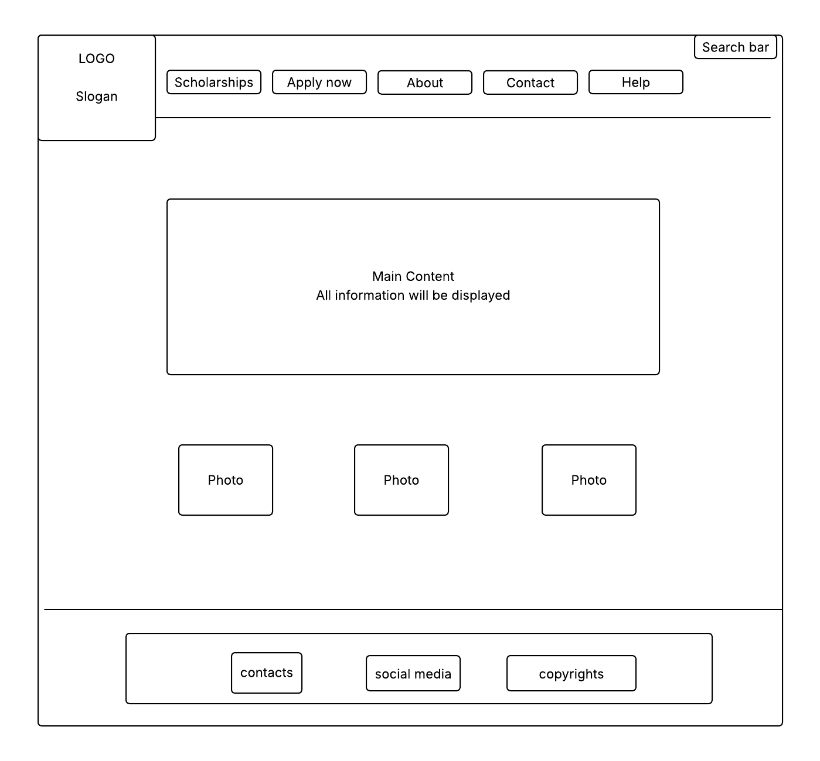

.Header-Includes the logo, slogan, navigation buttons and a search bar.
. Main Content area-all information will be displayed here.
. Image Section- The placeholders boxes will display photos and media.
.Footer- contains links for contacts, social media and copyrights.

Technologies Used
- HTML5 – used to structure the website
- CSS3 – used to style and design the website
Tools Used
- Visual Studio Code – used for writing and editing code
- GitHub – used to store and manage project files
- GitHub Pages – used to publish the website online

Testing
The website will be tested using web browsers such as Google Chrome to ensure that all pages load correctly and that navigation works as expected.

